Cryptographic system and method using insertion of random chars
Wiktor Nguyen
nguyenwiktor@gmail.com
ABSTRACT
System and method for encryption and decryption of data is presented.

BRIEF DESCRIPTION OF DRAWINGS
Fig. 1 Presents insertion of random chars into plaintext in positions marked by series of numbers generated by encrypting initial series of numbers presented in detailed description of invention first step.
Fig. 2 Presents selection of random numbers that will be xored with plaintext chars presented in detailed description of invention second step.
Fig. 3 Presents selection of random numbers that will indicate permutation of numbers 1,2,3...n where n is length of plaintext that will be used to rearange chars of plaintext presented in detailed description of invention third step.

DETAILED DESCRIPTION OF INVENTION
System is composed out of following components:
1 Input and output modules to get data known as plaintext and password from user and to return ciphertext.
2 RNG to generate random data that will be inserted into plaintext.
3 Predefined series of numbers k-times longer than plaintext where k is arbitrary chosen number larger than zero.
4 Encryption modules used to encrypt predefined series of numbers. This can be any symetric encryption algorithm like AES-256, triple DES, Kuznyechik, SM4 or any other.

First step.
Arbitrary number k need to be chosen. Furthermore initial series of numbers with length equal to k times length of plaintext or more is needed. This series of numbers is encrypted using Encryption algorithm for example AES-256. This way new series of numbers is obtained. Modified text is name that will be used for plaintext with inserted random data. Initialy modified text is equal to plaintext and its length is equal to length of plaintext. First number from new series of numbers is examined. It is multiplied by length of modified text and divided by maximum possible value of number in series of numbers, results will be called insertion position. RNG is used to generate k times length of plaintext random chars. First random character will be inserted into plaintext on position equal to insertion position after two following steps will be performed. Now modified text comprise of plaintext and one inserted random char. Its length is equal to plaintext length plus one. Process will be repeated for each of numbers in new series of numbers for each following generated random number after two following steps will be performed.
Once completed modified text is ciphertext.
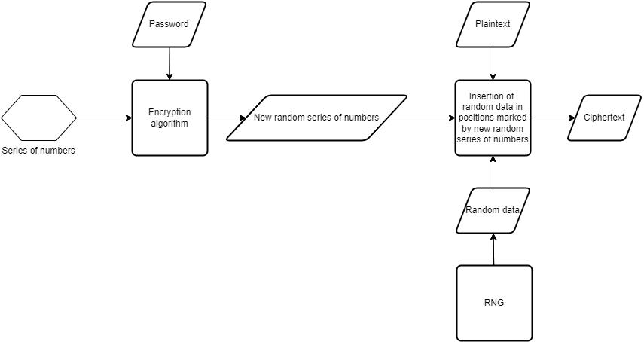
Second step.
Second series of numbers is given with second encryption algorithm and second password to obtain second new random series of numbers. Each of numbers generated in second series of numbers is multiplied by k times length of plaintext divided by number of possible diffrent chars generated.(size of used alphabet) This second random series of numbers determines which randomly generated numbers will be xored with chars in plaintext. Each number from second random series is treated as index pointing to random generated number(generated by RNG to be inserted). Pointed random generated number is multiplied by k times length of plaintext divided by number of possible diffrent chars generated.(size of used alphabet) Result is new index and randomly generated char with this index will be xored with 1st char of plaintext. This step is repeated for following chars from plaintext.
For example if second random series contains numbers 4,5,1 then 4th 5th and 1st random numbers will be taken. Let random numbers generated by RNG be 1,3,5,8,2,7,6 than 4th number is 8 so 8th random number which is 6 will be xored with first char of plaintext. 5th number is 2 so 2nd random number which is 3 will be xored with second char. Finly 1st number is 1 so first random number which is 1 will be xored with 3rd char of plaintext. This step can be optionaly simplified by xoring random numbers from second series with consequitive chars from plaintext rather than treating them as indexes to other random numbers.
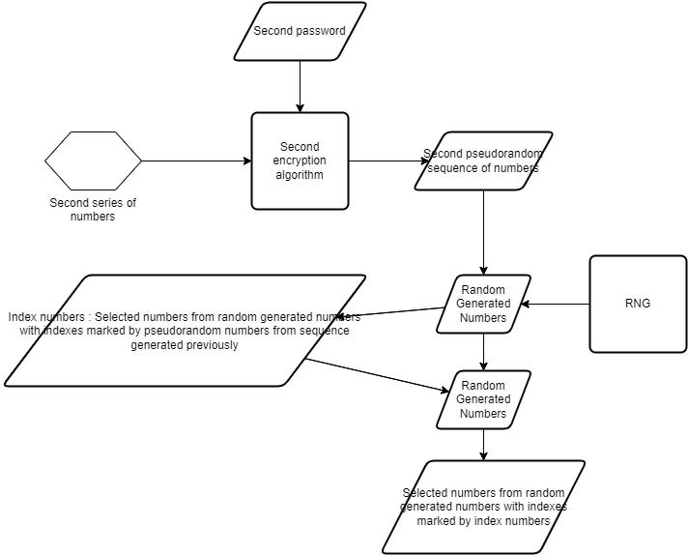
Third step.
Finally third series of numbers is given with third encryption algorithm and third password to obtain third new random series of numbers. Each of numbers generated in third series of numbers is multiplied by k times length of plaintext divided by number of possible diffrent chars generated.(size of used alphabet).This third random series of numbers is used to take random chars generated on positions determined by series. For example for series 4,2,7 4th 2nd and 7th randomly generated chars will be taken. Those randomly generated chars are taken as arguments by function called permutation function that returns permutation of series 1,2,3… n where n is length of plaintext. Permutation function can be any procedure that takes sequence of n random numbers and returns permutation of series 1,2,3...n. It can be constructed as follows. Get sequence of random numbers for example 1,32,5,127,5. Copy it and sort copy in ascending order. Now sorted copy is 1,5,5,32,127. To each random number in sorted copy ascribe index equal to its position in sequence. So 1 gots index 1, 5 gots index 2, 32 got index 4 and 127 gots index 5. Ascribe to sequence of random numbers its indexes so to sequence 1,32,5,127,5 numbers 1,4,2,5,3 are ascribed where to second occurance of 5 number 1 larger than orginal index is ascribed. Given this permutation plaintext is reordered in order described by permutation. For example for permutation 1,3,2 first letter of plaintext is put in first position, third letter of plaintext is put on second position and second letter of plaintext is put on position 2. Its possible to skip usage of second and or third password and just use predefined sequence of elements or to reuse password for first step in second step and or third step.
